Tugas IMPAL (Whitebox Testing)

Nama : Soraya Ihsanti

Kelas : IFIK-41-03

NIM : 1301172732

* Code :

a = int (input("masukkan nilai sisi 1 = "))

b = int (input("masukkan nilai sisi 2 = "))

c = int (input("masukkan nilai sisi 3 = "))

if (a>0 and b>0 and c>0) :

if (a==b and b==c) :

print ("Segitiga Sama Sisi")

elif (a==b or a==c or b==c) :

print ("Segitiga Sama Kaki")

elif (a\*\*2+b\*\*2==c\*\*2 or a\*\*2+c\*\*2==b\*\*2 or b\*\*2+c\*\*2==a\*\*2) :

print ("Segitiga Siku-siku")

else :

print ("Segitiga Bebas")

* Basic Path :

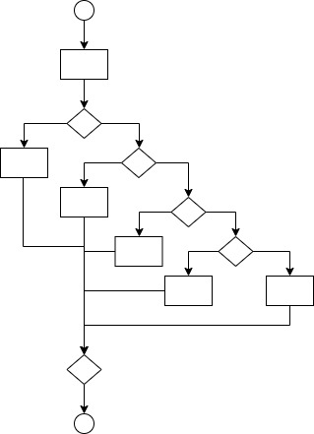

* Cyclomatic

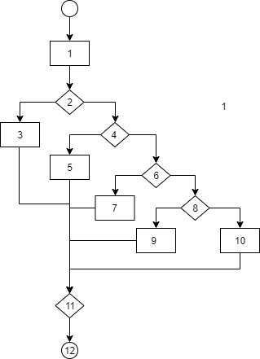

V(G) = 5,

Path 1 : 1,2,3,11,12

Path 2 : 1,2,4,5,11,12

Path 3 : 1,2,4,6,7,11,12

Path 4 : 1,2,4,6,8,9,11,12

Path 5 : 1,2,4,6,8,10,11,12